**Project Management**

Assessment Two

Full Name: Maria del Carmen Farfan Guevara Student ID: 18004

Wells international college

|  |  |  |  |
| --- | --- | --- | --- |
| Name of Student | Maria del Carmen Farfan Guevara | ID | 18004 |

**Assessment 2 – Research (Online)**

Contents

Instructions: 1

Duration: 2

Multiple-choice Questions: 2

Learning Notes: 11

Please put your learning notes here: 11

Project management basic 13

Project management History 14

Project management in the future 15

Project Team 15

Document Search Index 16

## Instructions:

This is an individual assessment. Answer all the questions on the document provided by your Trainer.

## Duration:

Trainer will set the duration of the assessment.

## Multiple-choice Questions:

1. 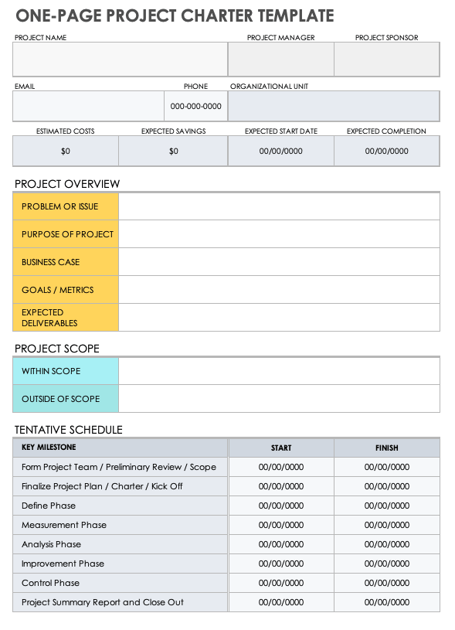What advice do we give about factoring in the commitments of project stakeholders when making your own plans?
   1. Consult student timetables to see when they might be free to attend data collection sessions.
   2. Ask external organizations what the most convenient times would be for you to visit
   3. Neither of these

d) Both A and B

Comment: Keep your stakeholders aware and informed if there are any changes in the process.

Web ref: <https://www.kahootz.com/why-stakeholder-management-is-an-important-part-of-project-management/>

1. Which of the following are essential components of a GANTT chart used to plan your project?
   1. Your home telephone number
   2. Your supervisor’s home telephone number
   3. The email address for the chair of the ethics committee
   4. None of the above

Comment: Some of the essential elements to make a grant chart are the list of tasks to be carried out, the start and end date, the progress of each task

Web ref: <https://thedigitalprojectmanager.com/what-should-gantt-chart-include/#:~:text=Even%20a%20simple%20Gantt%20chart,%2C%20at%20risk%2C%20or%20delayed%3F>

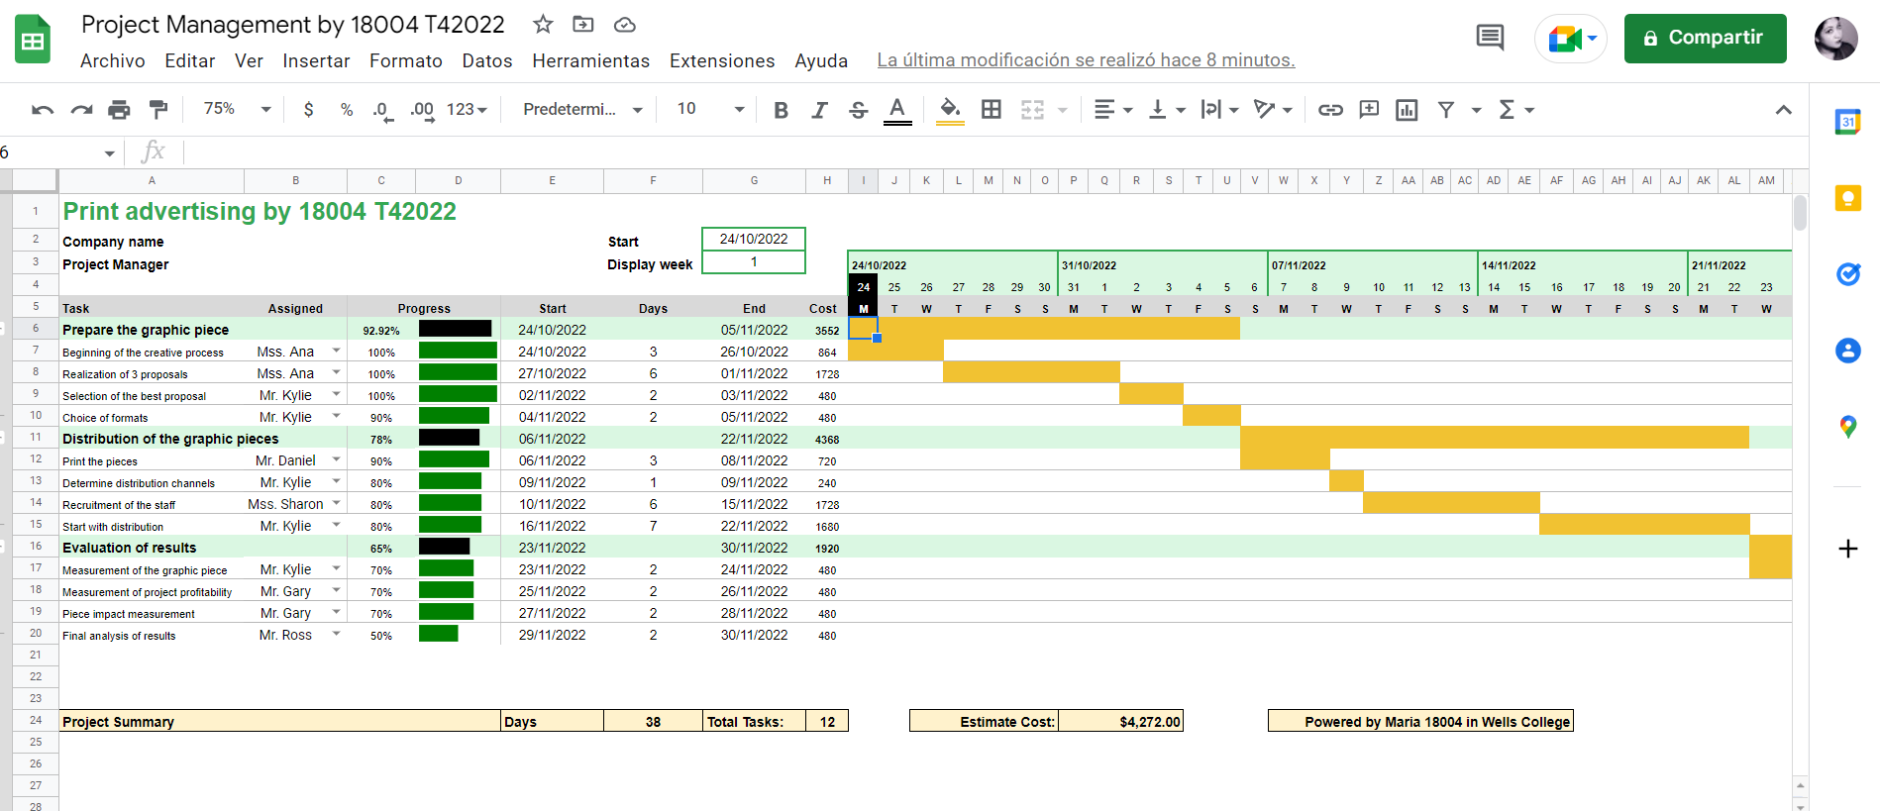

1. The intended outcome of strategy/projects integration is
   1. 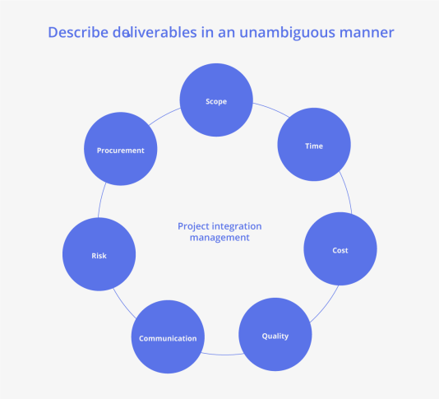Clear organization focus
   2. Best use of scarce organization resources
   3. Improved communication across projects and departments
   4. Both A and C are correct
   5. A, B, and C are all correct

Comment: As a manager, the primary approach is to get the project done within the allocated resources and timeframe. How did it become possible? You have to synchronize all the processes of the projects to execute them effectively. Moreover, you need to optimize the project dependencies, stakeholders’ expectations, consumer preferences, and all the necessary aspects of projects to develop a unified approach.

Web Refer: <https://www.teamboard.cloud/project-integration-management/>

1. Which of the following questions does the organization's mission statement answer?
   1. 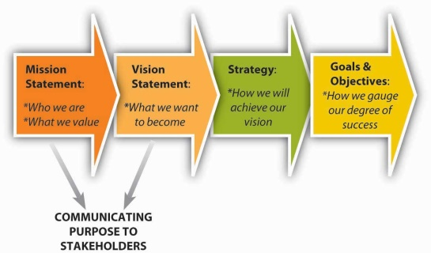What are our long-term strategies?
   2. What are our long-term goals and objectives?
   3. How do we operate in the existing environment?
   4. What do we want to become?
   5. All of these are answered by the mission statement

Comment: A mission statement is a concise explanation of the organization's reason for existence. It describes the organization's purpose and its overall intention. The mission statement supports the vision and serves to communicate purpose and direction to employees, customers, vendors and other stakeholders.

Web Refer: <https://www.shrm.org/resourcesandtools/tools-and-samples/hr-qa/pages/isthereadifferencebetweenacompany%E2%80%99smission,visionandvaluestatements.aspx#:~:text=A%20mission%20statement%20is%20a,customers%2C%20vendors%20and%20other%20stakeholders>

1. 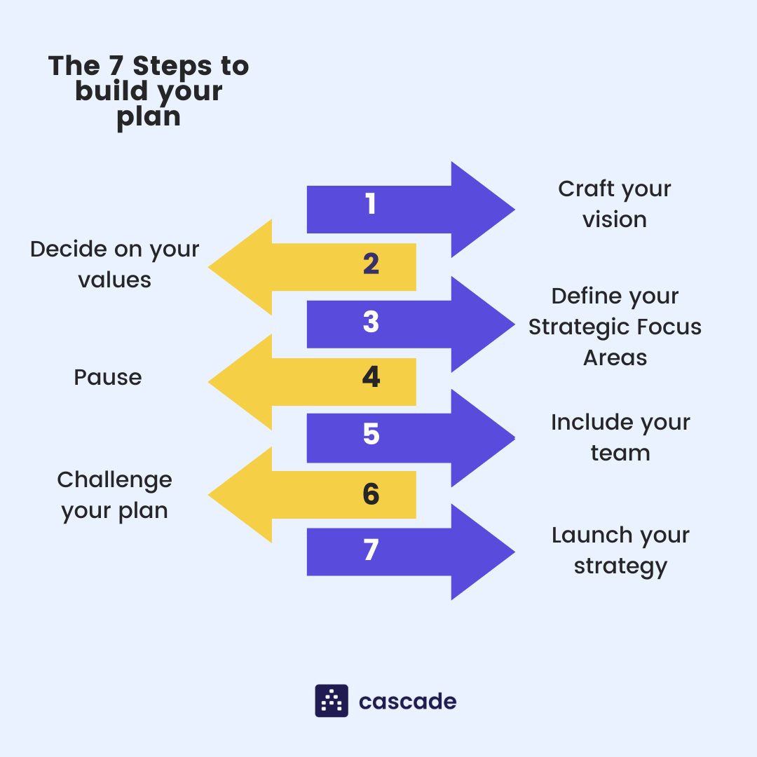Which of the following is not one of the requirements for successful implementation of strategies through projects?
   1. Allocation of resources
   2. Prioritizing of projects
   3. Motivation of project contributors
   4. Adequate planning and control systems
   5. All of these are requirements

Comment: **Strategy implementation** is the process of turning plans into action to reach a desired outcome. Essentially, it’s the art of getting stuff done. The success of every organization rests on its capacity to implement decisions and execute key processes efficiently, effectively, and consistently.

Web refers: <https://online.hbs.edu/blog/post/strategy-implementation-for-managers>

1. Which of the following is the reason(s) why project managers need to understand their organization's mission and strategy?
   1. 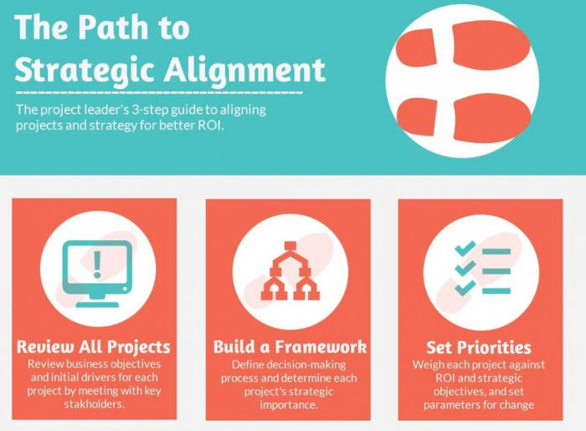To make appropriate decisions and adjustments
   2. To be effective project advocates
   3. To be able to get their job done

d) Both A and B are correct

* 1. A, B, and C are all correct

Comment: Understanding the company strategy helps a project manager to frame requests in ways that are more likely to gain them backing and positive feedback. If a project manager can tie value into both their team members as well as senior stakeholders, the chances of project success are much greater.

Web refers: <https://blog.planview.com/project-managers-care-business-strategy/#:~:text=Understanding%20the%20company%20strategy%20helps,project%20success%20are%20much%20greater>

1. Which of these is the highest priority and first strategy required for any organizational change?

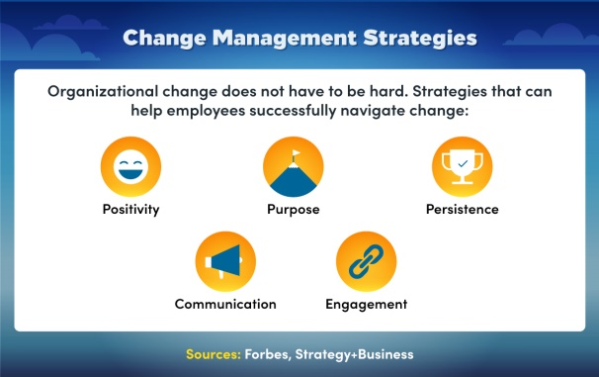a) Communication

* 1. Stress management
  2. Negotiation
  3. Learning
  4. Employee involvement

Comment: Communication is the highest priority and first strategy required for any organizational change. It reduces the restraining forces by keeping employees informed about what to expect from the change effort.

Web refer: <https://online.champlain.edu/blog/best-organizational-change-management-strategies>

1. Which of the following is not a procedure to obtain an understanding risk in the planning stage (described in ISA 315):
   1. Inquiries of management
   2. Analytical procedures
   3. Observation and inspection

d) Procedures for sampling audit tests

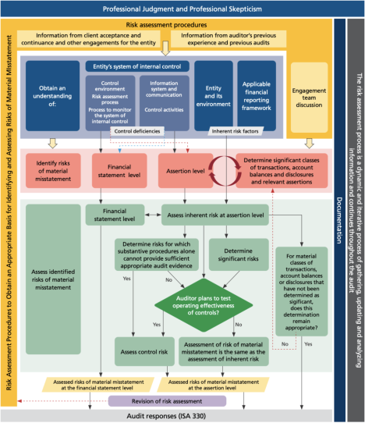

Comment: SA 315 (Revised 2019) has been enhanced to form a stronger foundation for the audit, in particular better quality risk identification and assessment is expected to enhance the procedures required by other standards such as ISA 3303 and ISA 540 (Revised)

Web refer: <https://www.ifac.org/system/files/publications/files/IAASB-ISA-135-first-time-implementation-guidance.pdf>

1. Assessment of control risk includes three steps. Which of the following is not one of these steps?
   1. 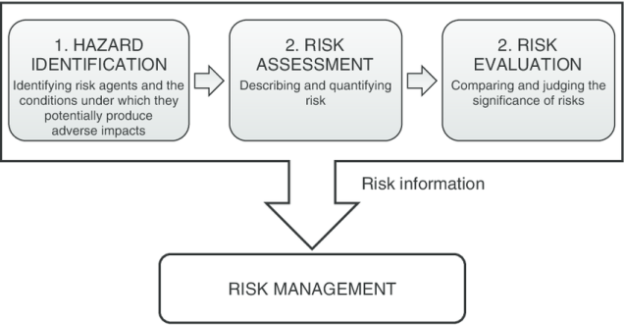Obtaining an understanding of internal controls and documentation of the controls
   2. Evaluate sufficiency and appropriateness of audit evidence
   3. An initial assessment and response to assessed risk based on the design of internal controls resulting in an audit planning memorandum and audit plan
   4. A final assessment based upon test of controls of operating effectiveness

Comment: Risk assessment is the name for the three-part process that includes: Risk identification, risk analysis, risk evaluation.

Web refer: <https://www.vectorsolutions.com/resources/blogs/three-phases-risk-assessment-risk-management-basics/#:~:text=Risk%20assessment%20is%20the%20name,Risk%20evaluation>

1. Which of the following are not common internal control documentation techniques used by auditors?

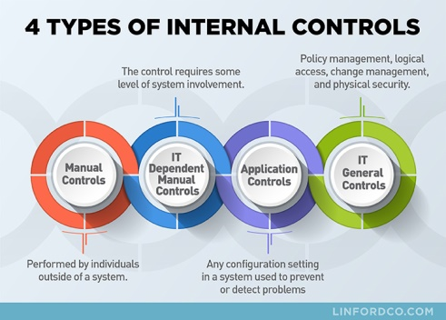a) Questionnaires

b) Company internal control manuals

* 1. Narrative descriptions
  2. Check lists

Comment: Internal controls are the mechanisms, rules, and procedures implemented by a company to ensure the integrity of financial and accounting information, promote accountability, and prevent fraud.

Web refer: <https://www.investopedia.com/terms/i/internalcontrols.asp>

1. Overall response to assessed risk may include:
   1. Identify the absence of key controls (where controls are lacking)
   2. Identify existing controls
   3. 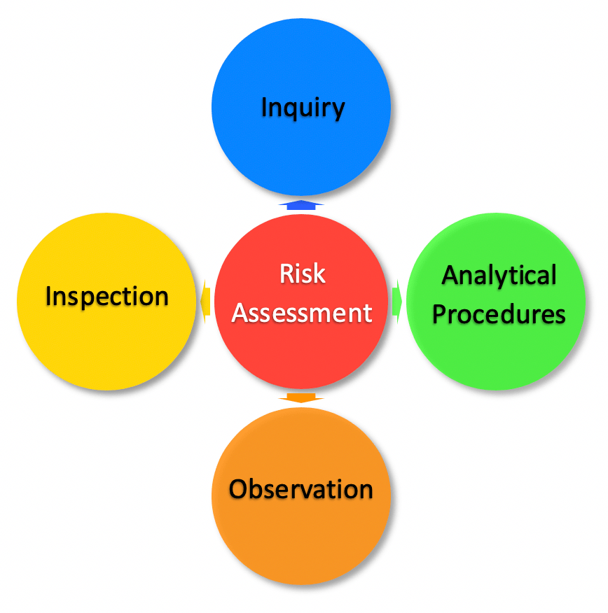Incorporating additional elements of unpredictability in the selection of further audit procedures to be performed
   4. Determine potential material misstatements that could result

Comment: Responses may include: Emphasising the need for professional scepticism; assigning more experienced audit staff; using specialists or experts; providing additional supervision; and incorporating further elements of unpredictability in the selection of audit tests.

Web refer: <https://library.croneri.co.uk/cch_uk/impg/21-4>

1. Action plan Should be
   1. 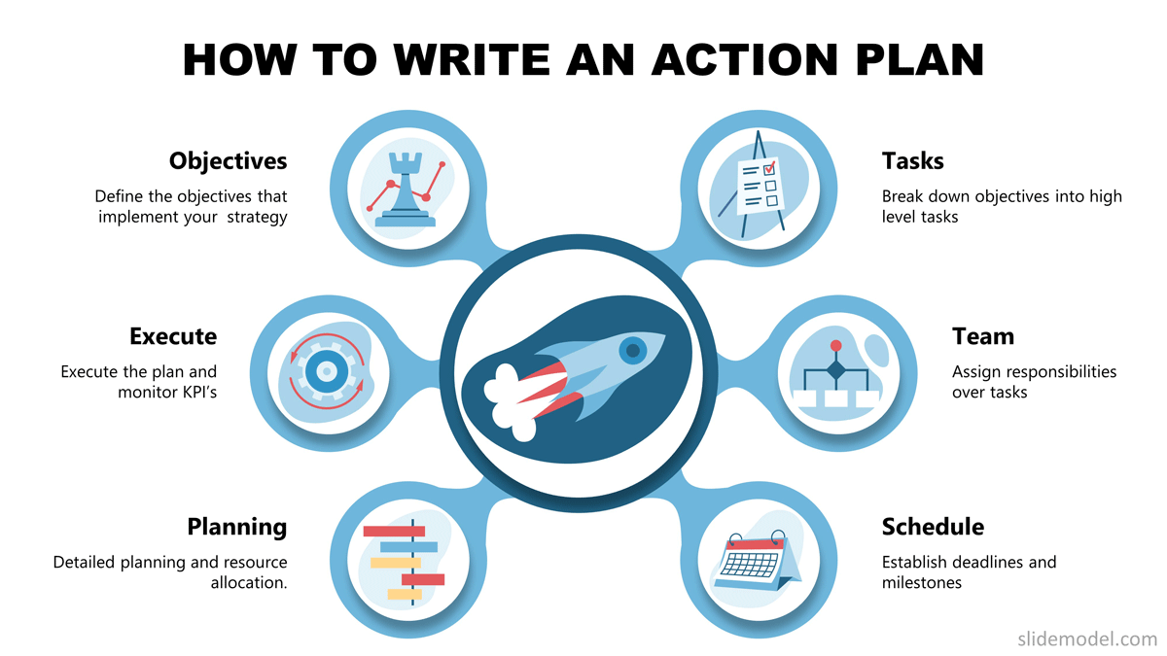Specific
   2. Countable
   3. Realistic
   4. Achievable

Comment: Develop an action plan composed of action steps that address all proposed changes. The plan should be complete, clear, and current. Additionally, the action plan should include information and ideas you have already gathered while brainstorming about your objectives and your strategies.

Web refer: <https://ctb.ku.edu/en/table-of-contents/structure/strategic-planning/develop-action-plans/main#:~:text=Develop%20an%20action%20plan%20composed,your%20objectives%20and%20your%20strategies>

1. Which of the following is not a function of Project Management Tool?
   1. Plan a project
   2. 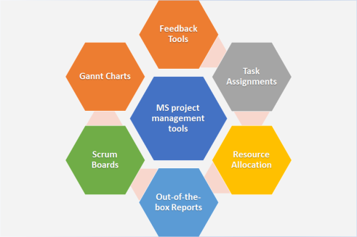Manage Tasks
   3. Manage Issues
   4. Time Tracking
   5. None of above

Comment: Project management tools are a set of software designed to help project teams to plan a project, track & manage the projects to achieve the defined project goals within the time. It also helps team members to collaborate effectively and accelerate the projects to meet the specified constraints.

Web refer: <https://www.zoho.com/projects/project-management-tools.html#:~:text=Project%20management%20tools%20are%20a,to%20meet%20the%20specified%20constraints>

1. John, the project manager for the ERP Project, is about to complete the project phase review. The completion of a project phase is also known as which of the following?

a) A lesson learned

* 1. A kill point
  2. 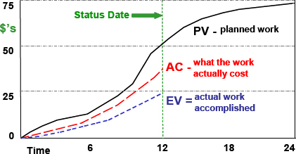Earned value management
  3. Conditional advancement

Comment: Earned value management (EVM) is a project management methodology that integrates schedule, costs, and scope to measure project performance. Based on planned and actual values, EVM predicts the future and enables project managers to adjust accordingly.

Web refer: <https://www.ecosys.net/knowledge/earned-value-management-basics/>

1. 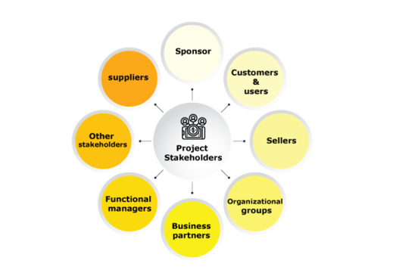Which of the following is not a key stakeholder in a project that creates a service internal to an organization?
   1. The project manager
   2. External customers
   3. Project vendors
   4. Project team members

Comment: Project stakeholders usually include the project manager, the customer, team members within the performing organization, and the project sponsor.

Web refer: <https://www.pmi.org/learning/library/stakeholder-analysis-pivotal-practice-projects-8905#:~:text=Project%20stakeholders%20usually%20include%20the,organization%2C%20and%20the%20project%20sponsor>

1. Managing a project is best described as which one of the following?
   1. 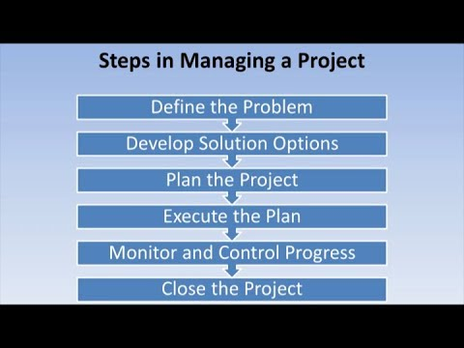Establishing direction
   2. Functional controls over the project team and stakeholders
   3. Consistently producing key results expected by stakeholders
   4. Motivating and inspiring the project team to produce results that are expected by project stakeholders

Comment: Project management is to plan and manage a project to successfully complete its listed goals and deliverables. It involves identifying and managing risks, careful resource management, smart budgeting, and clear communication across multiple teams and stakeholders.

Web refer: <https://www.lucidchart.com/blog/why-is-project-management-important>

1. 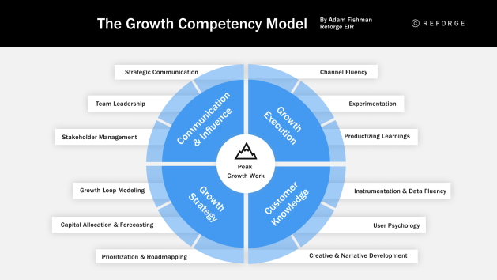You are the project manager for your organization. Influencing your organization requires which of the following?
   1. An understanding of the organizational budget
   2. Research and documentation of proven business cases
   3. An understanding of formal and informal organizational structures
   4. Positional power

Comment: Many fundamental steps and guides in the project management processes are taken for granted because they seem very basic and obvious. This includes better and more factual testing methods, communication processes and protocols, and the role of key staff members and project manager. This results in many problems like

* Delays in execution that result in missed deadlines
* Uncertainty about the exact deliverables and expectations
* Confusion about the direction of the execution, work requirements, and project status
* Dissatisfaction in the client due to the quality of deliverables.

Web refer: <https://opentextbc.ca/projectmanagement/chapter/chapter-5-project-stakeholders-project-management/>

1. What is the difference between a standard and a regulation?
   1. 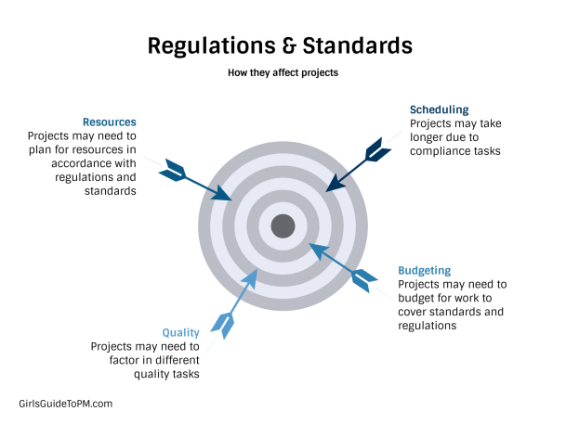Standards are mandatory; regulations are not.
   2. Standards are optional; regulations are not.
   3. Regulations and standards are essentially the same.
   4. Regulations are usually mandatory; standards may be seen as guidelines.

Comment: When you’re planning how to deliver quality results, and what needs to go into your project schedule, it’s worth looking at what regulations and standards you need to adhere to.

Web refer: <https://www.projectmanagement.com/blog-post/52929/The-Difference-Between-Regulations-and-Standards>

1. 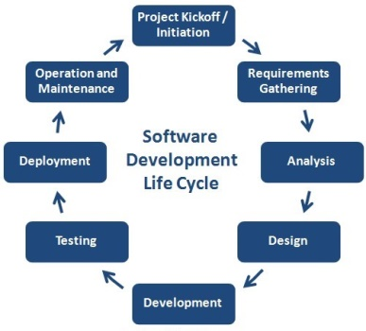Which of the following is an example of a deliverable at the end of the requirements-gathering phase in a software design project?
   1. Responsibility matrix creation
   2. Detail design document
   3. Business needs
   4. Project team assembled

Comment: The design phase in software development is to determine the software and hardware architecture of the software product according to the requirements specified in the initial requirement analysis phase.

Web refer: <https://www.devteam.space/blog/how-to-conduct-the-design-phase-in-software-development/>

1. At what point in a project would a kill point be acceptable?
   1. 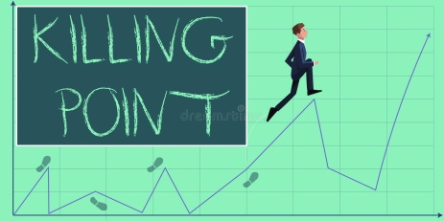When a project team member is not performing as planned
   2. When a project reaches the end of a project phase
   3. When a project reaches the end of its budget
   4. When a project manager determines the project team cannot continue

Comment: Kill points are when the stakeholders decide that the project is not worth completing in its current state. It may be restarted with different criteria.

Web refer: <https://certifedpmp.wordpress.com/tag/kill-points/>

1. 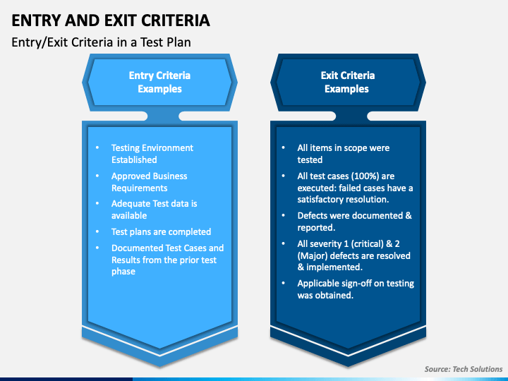Of the following, which is not an exit criterion?
   1. Customer sign-offs
   2. Quality metrics
   3. Stakeholder analysis
   4. Regulatory inspections

Comment: Exit criteria are the criteria or requirements which must be met to complete a specific task or process as used in some fields of business or science, such as software engineering.

Web refer: <https://en.wikipedia.org/wiki/Exit_criteria>

1. At which point is the risk of failure the least but the consequence of failure the highest?

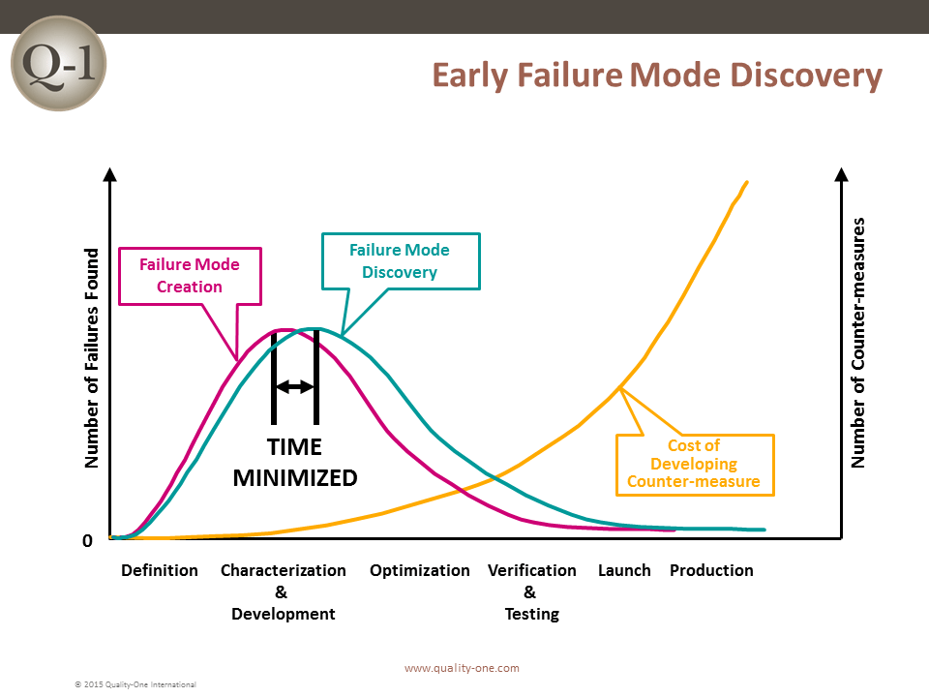a) During the early stages

* 1. During the middle stages
  2. During the final stages
  3. Risk of failure is even across all project phases

Comment: While project failure risk is present in every stage, the likelihood of project failure derives mostly from the Initiating and Planning stages.

Web refer: <https://www.mentorworks.ca/blog/business-strategy/project-failure-risk-strategies/>

1. In project estimation, project manager has to provide an expert judgement, which are considered of the following EXCEPT:
   1. Impact of inflation over the project lifecycle
   2. 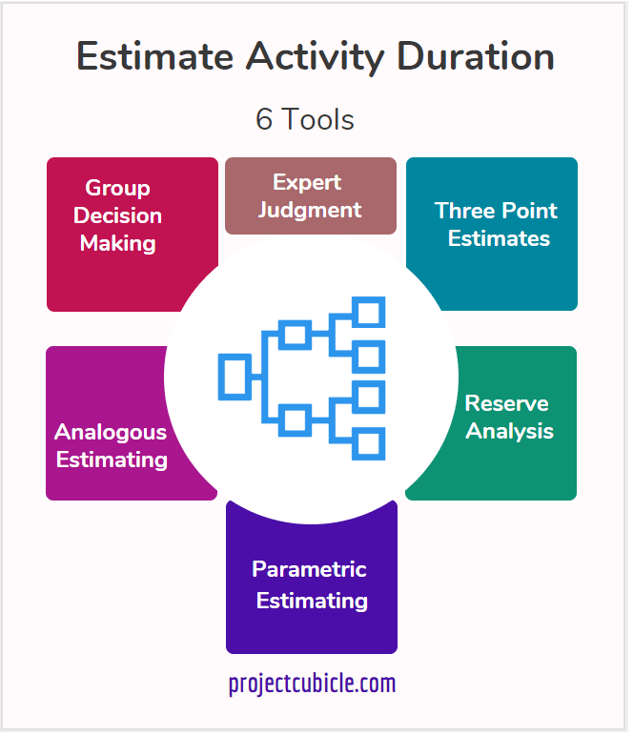Required labour and labour rates
   3. Material costs and assumptions
   4. Costs of quality
   5. All of above
   6. None of above

Comment: Expert judgment is when you call in an expert to get a skilled opinion. It's an estimation methodology for project planning that relies on the expert's opinion to estimate quantitative project details, such as timelines and potential resources.

Web refer: <https://asana.com/resources/expert-judgment>

1. 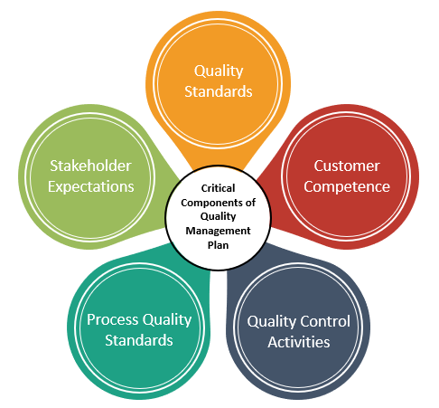Which component is/are included in Quality Management Plan
   1. Quality objectives
   2. Key project deliverables
   3. Quality standards
   4. Quality control and assurance activities
   5. All of above

Comment: **Project Quality Management is the discipline that is applied to ensure that both the outputs of the project and the processes used to deliver the outputs meet the required needs of the stakeholders. Quality is broadly defined as fitness for purpose.**

Web refer: <https://www.parallelprojecttraining.com/blog/describe-the-four-main-components-of-a-quality-management-process/#:~:text=The%20four%20main%20components%20of%20a%20quality%20management%20process%20are,Quality%20Control%20and%20Continuous%20Improvement>

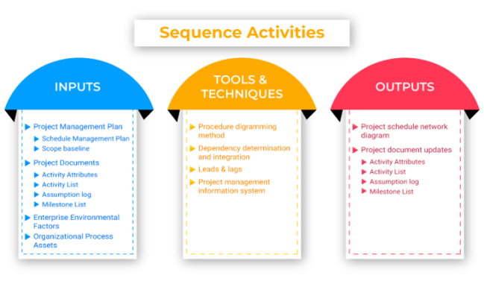

1. What's an activity sequencing
   1. The process for identifying and documenting dependencies among schedule activities
   2. The process for identifying critical activities
   3. The process for identifying ordering and schedule activities
   4. The process for planning the project

Comment: **Activity Sequencing** involves the accurate identification of constraints/relationships among activities and establishing the order in which the activities will be accomplished.

* The activity list developed in the Activity Definition step,
* The product description and characteristics,
* Mandatory constraints/dependencies, such as the fact that a prototype must be fabricated before it can be tested,
* Discretionary constraints/dependencies developed by the program management team based on “best practices” or specific sequences desired by management,
* External dependencies, such as availability of test sites, and
* Other constraints and assumptions.

Web refer: <https://acqnotes.com/acqnote/tasks/activity-sequencing>

## Learning Notes:

<https://www.youtube.com/watch?v=rBSCvPYGnTc&t=1323s>

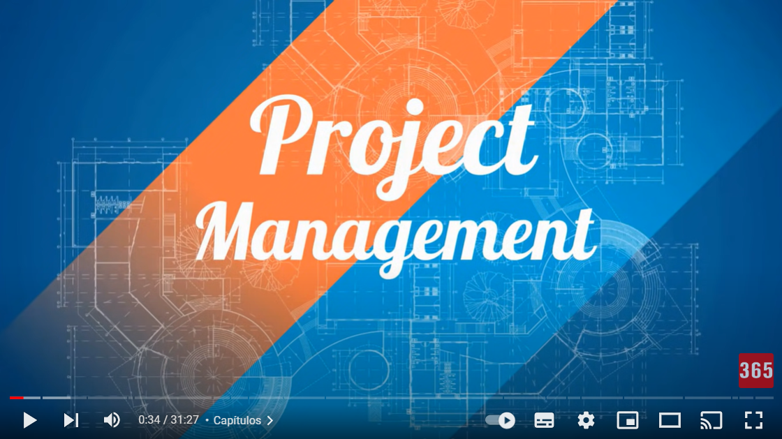

## What is project?

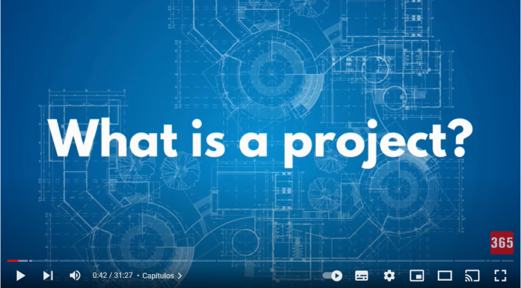

A project is a temporary endeavour undertaken to create a unique product, service or result

Should have a time (start and end date) , a scope (product, service or result) and a cost (the specific resource).

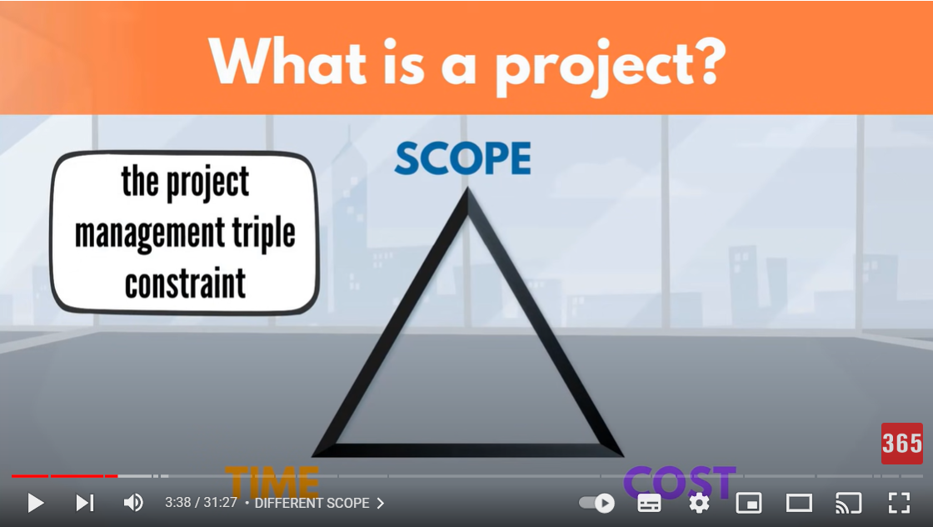

## Please put your learning notes here:

## Project management basic

A project must relate to a business strategy. A Few key triggers that will start business into executing a project. They might need:

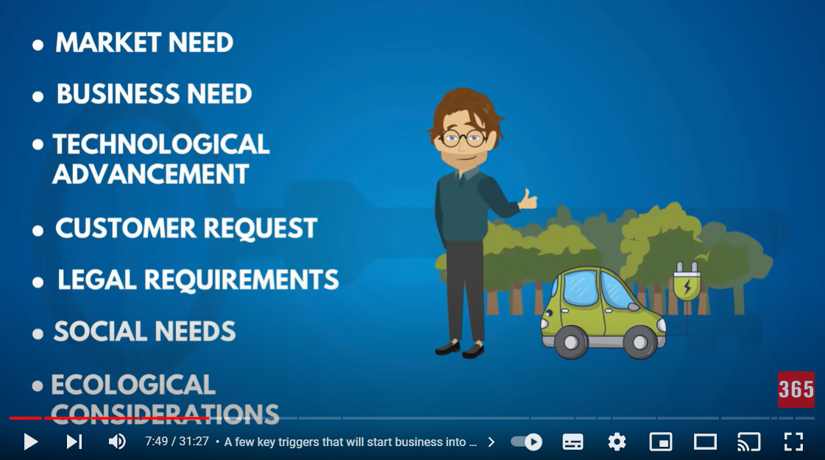

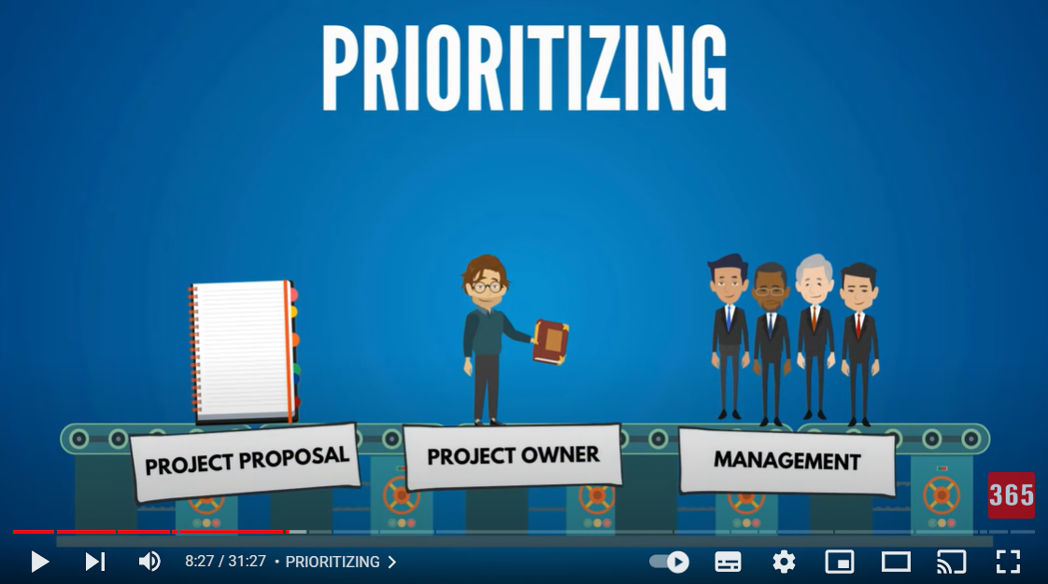

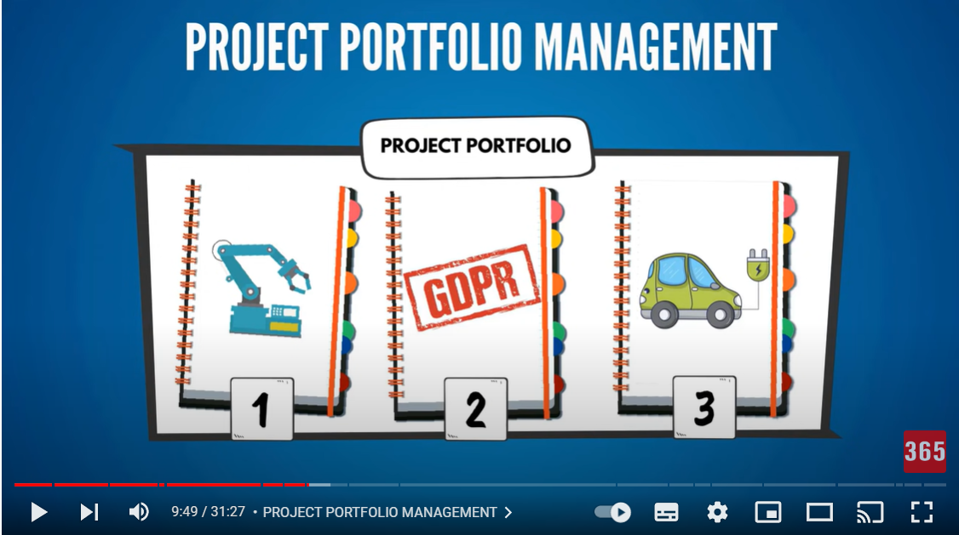

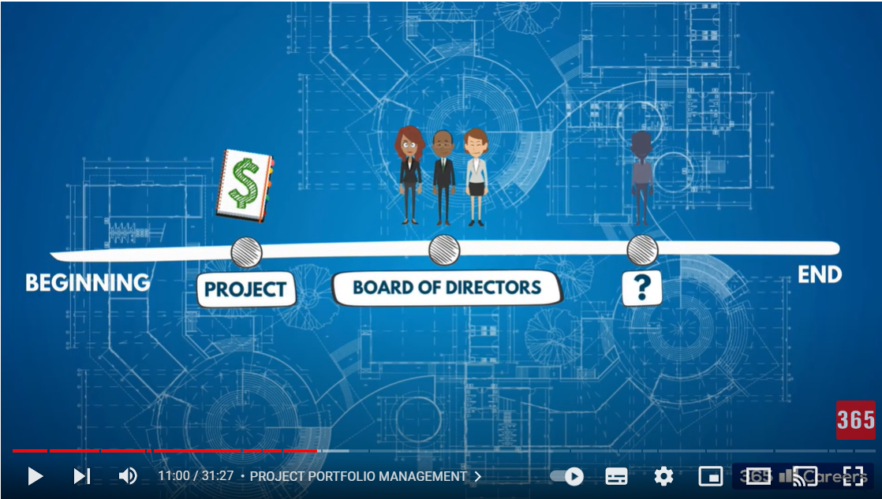

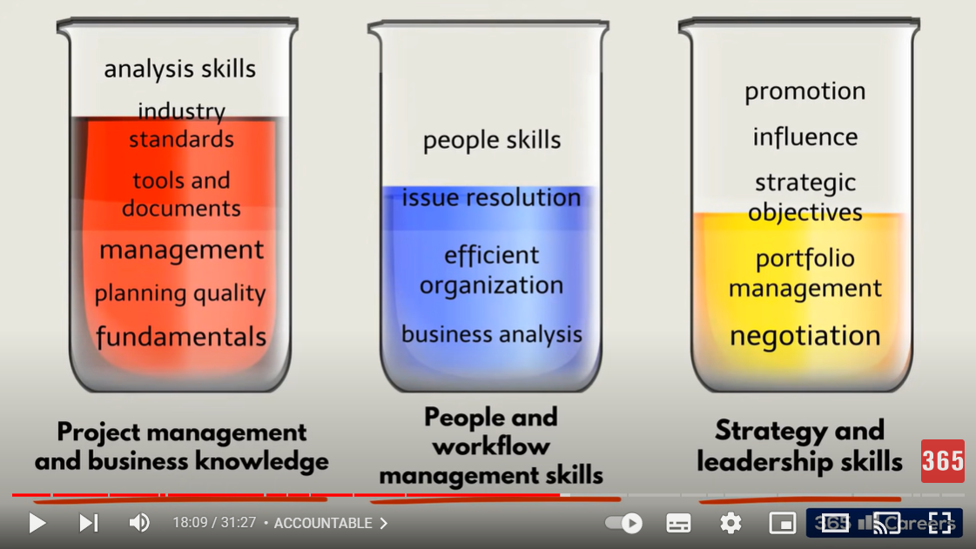

## Project management History

Initiatives with a specific goal and constraints have been happening for thousands of years. For example:

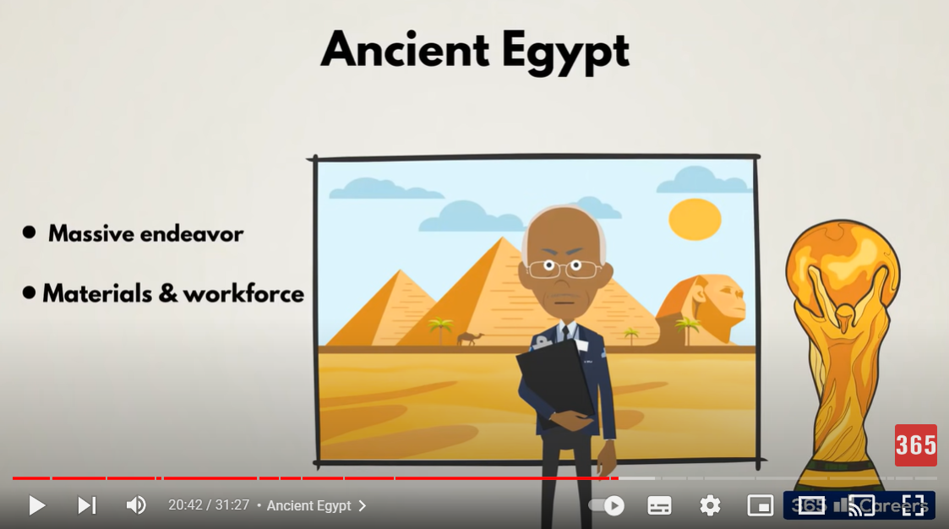

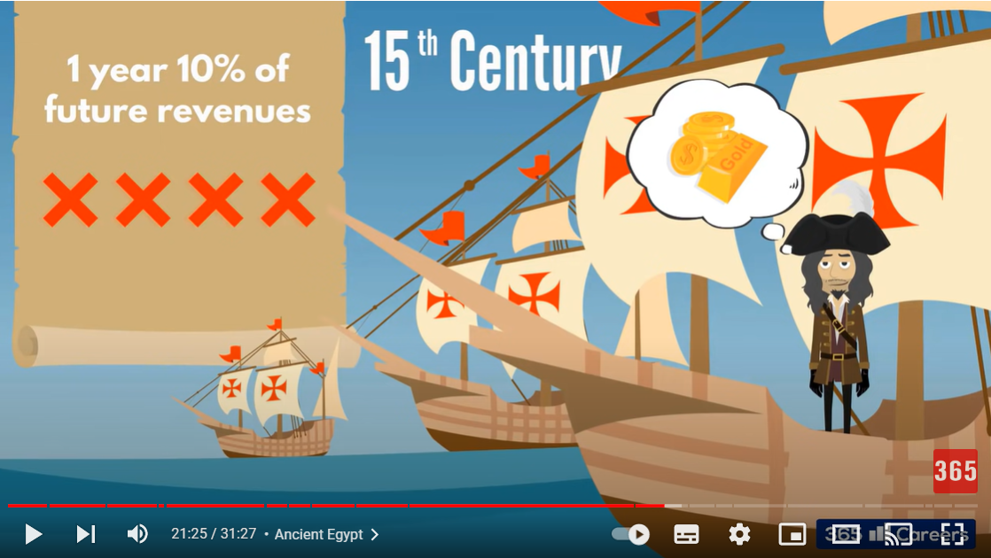

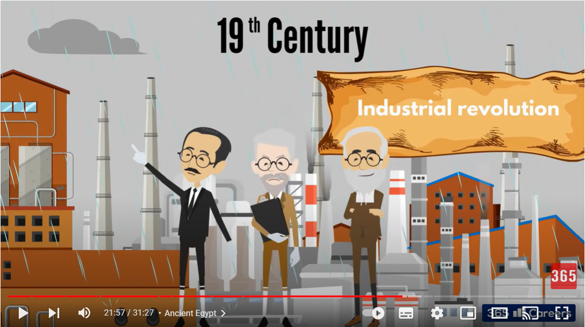

20 Century the Henry Gantt first make Gantt Chart Diagram. It is the revolution to know more about project management.

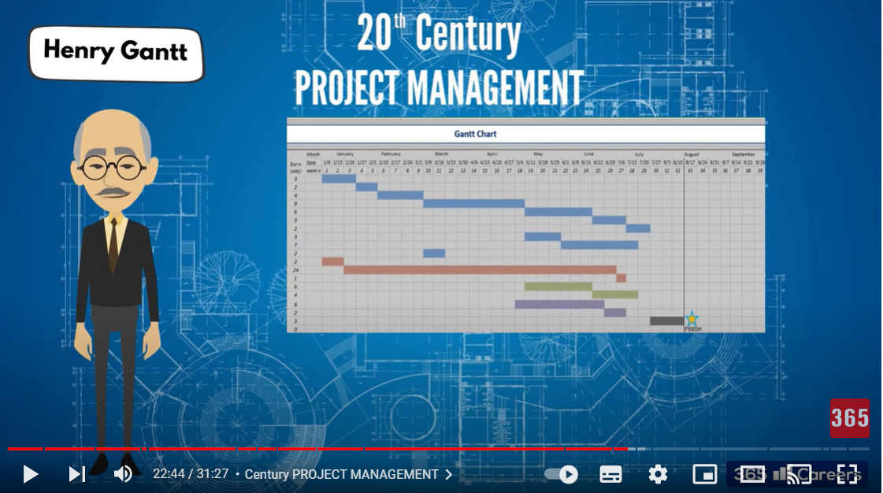

## Project management in the future

In 60s project management was stablish as a profession

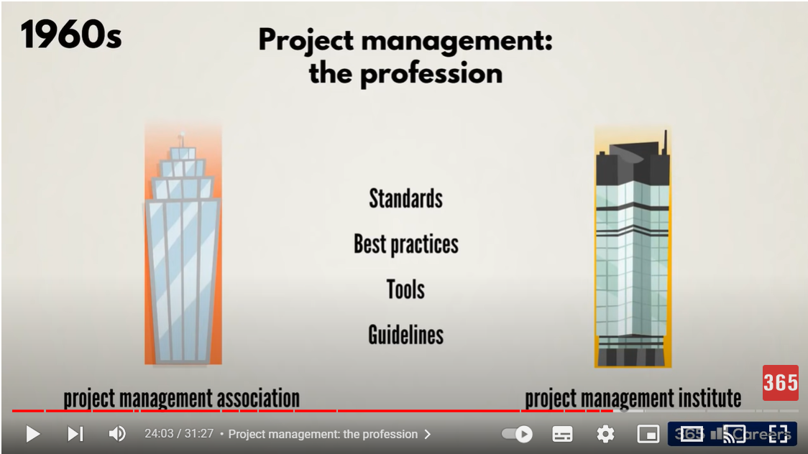

## Project Team

The project Team are the experts responsible for the execution of the work. For example HR, Engineer, web designer, construction worker, etc.

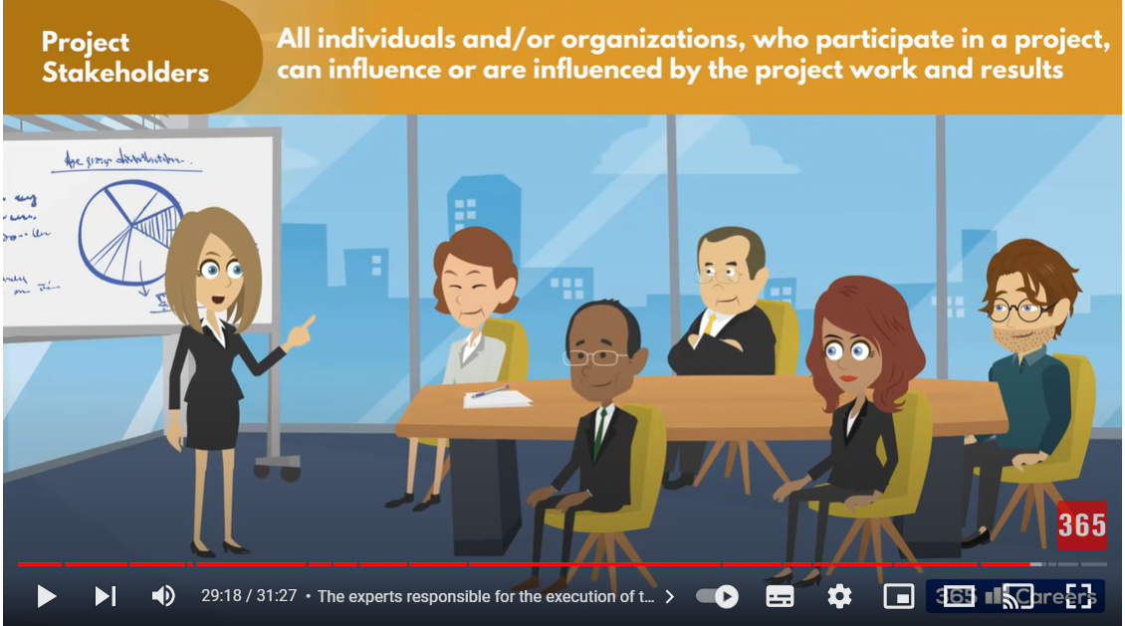

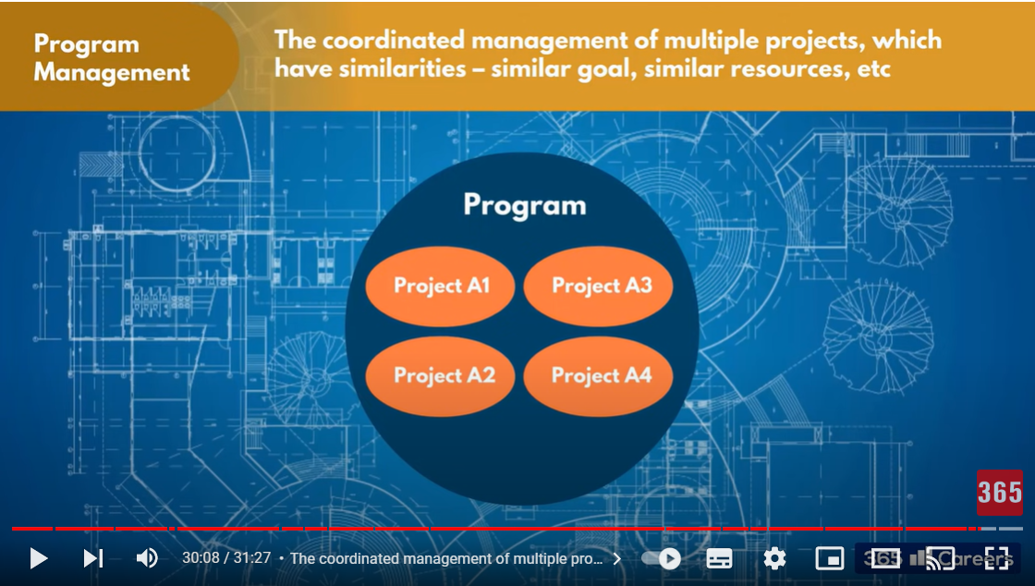

## Document Search Index

A

a GANTT chart 2

M

mission and strategy 3

mission statement 3

O

organizational change 3

P

project stakeholders 2

projects integration 2

S

successful implementation 3

U

understanding risk 4